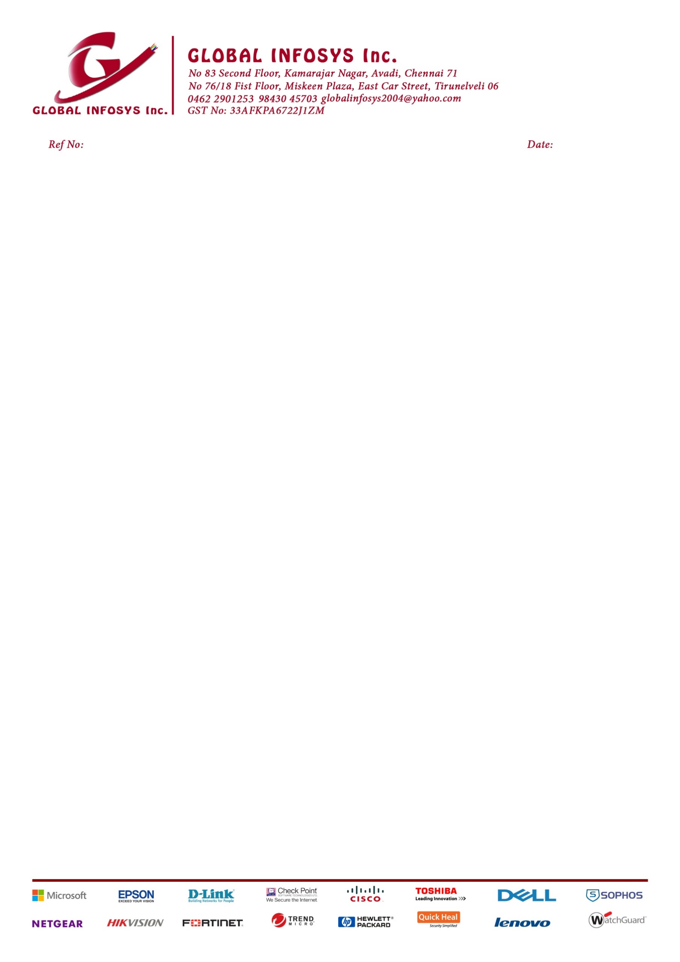

16 June 26

INTERNSHIP TRAINING CERTIFICATE

This is to Certify that Mr. P.G. YUKANTHAN – PSR ENGG. COLLEGE, SIVAKASI 2nd Year Student participate the Internship for Computer System Service, Networking and Solution in the period of 1 June 2026 – 15 June 2026.
During this period they trained for Computer system Assembling, Configure and Software Installation, Printer & Scanner installation, Networking between the computers and Internet configuration also inside and outside in Customer site.
They are all very supportive, cooperative and understanding the work in the way as our requirements.
During this period, they attend properly in good manner, discipline and very sincere to participate the work what we given to them. They performed well and cooperative in understanding our requirements with our good satisfaction. We wish them all the students are get good, bright for their future endeavor.
WISHING HIM GOOD LUCK FOR THEIR BRIGHT FUTURE.

With Regards,
GLOBAL INFOSYS INC



